Project Plan
5 hours per person per week * 4 people * 8 weeks = 160 hours to work with
Tasks, durations, and dependencies
Task ID | Task | Effort in hours | Dependencies
T1 | Create customer | 4 | T12
T2 | Create newsagent | 4 | T12
T3 | Create delivery person | 4 | T12
T4 | Create order book | 4 | T12
T5 | Create publications | 4 | T12
T6 | Create delivery docket | 4 | T12
T7 | Create delivery area | 4 | T12
T8 | Create bill | 4 | T12
T9 | Set up database | 2 | T1
T10 | Implementing database | 8 | T1-T4
T11 | Set up GUI | 8 | T1-T8

Allocation Table
Week | Michael | Joseph | Luke | James
1 | T9 | T1 | T2 | T2
2 | T10 | T3 | T2 | T2
3 | T10 | T3 | T3 | T3
4 | T10 | T4 | T4 | T4
5 | T10 | T11 | T5 | T5
6 | T10 | T11 | T6 | T6
7 | T10 | T11 | T7 | T7
8 | T10 | T11 | T11 | T11

First Increment Functionality - 2 week increment
- Finish User Stories – Michael, Luke
- Work on project plan - James
- Customer – Joseph – Pair processing - Luke, James
- News Agent – James, Luke
- Setting up database, linking customer - Michael
- Do TDD tutorial - Joseph
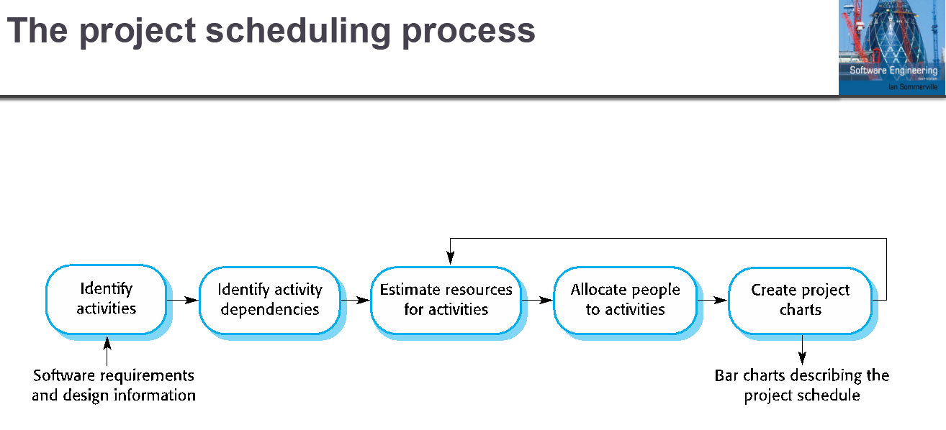
- Work on software cycle reasoning - James

